

Network Security and Forensics

Lab Session 8

Submitted To:- Submitted By:-

Dr. Lokesh Chauhan Sir Saloni Rangari

M.Tech. AIDS

**Assignment 1: Write a program to demonstrate Deffie Hellman algorithm by taking input of global parameters and private keys from a file and produce Public Key and Shares Keys into the output file.**

def read_parameters(file_path):try:  
 with open(file_path, 'r') as file:  
 lines = file.readlines()  
 if len(lines) < 4:  
 raise ValueError("Input file must contain at least 4 lines.")  
 p = int(lines[0].strip()) # Prime number  
 g = int(lines[1].strip()) # Generator  
 a_private = int(lines[2].strip()) # Private key for A  
 b_private = int(lines[3].strip()) # Private key for B  
 return p, g, a_private, b_private  
 except ValueError as ve:  
 print(f"Value error reading parameters: {ve}")  
 raise  
 except Exception as e:  
 print(f"Error reading parameters: {e}")  
 raise  
  
def write_keys(file_path, a_public, b_public, shared_key):try:  
 with open(file_path, 'w') as file:  
 file.write(f"A's Public Key: {a_public}\n")  
 file.write(f"B's Public Key: {b_public}\n")  
 file.write(f"Shared Key: {shared_key}")  
 except Exception as e:  
 print(f"Error writing keys: {e}")  
 raise  
  
def diffie_hellman(file_input, file_output):try:  
 p, g, a_private, b_private = read_parameters(file_input)  
  
 # Calculate public keys  
 a_public = pow(g, a_private, p) # A's public key  
 b_public = pow(g, b_private, p) # B's public key  
  
 # Calculate shared secret  
 shared_key_a = pow(b_public, a_private, p) # Shared key calculated by A  
 shared_key_b = pow(a_public, b_private, p) # Shared key calculated by B  
  
 assert shared_key_a == shared_key_b # Both should be the same  
  
 write_keys(file_output, a_public, b_public, shared_key_a)  
 except Exception as e:  
 print(f"Error in Diffie-Hellman key exchange: {e}")  
 raise

if __name__ == "__main__":  
 input_file = 'input.txt'  
 output_file = 'output.txt'  
  
 diffie_hellman(input_file, output_file)  
 print("Diffie-Hellman key exchange completed successfully.\n")

# Show the input with labels  
 print("Input from input.txt:")  
 with open(input_file, 'r') as file:  
 lines = file.readlines()  
 p = int(lines[0].strip()) # Prime number  
 g = int(lines[1].strip()) # Generator  
 a_private = int(lines[2].strip()) # Private key for A  
 b_private = int(lines[3].strip()) # Private key for B  
  
 print(f"Prime number (p): {p}")  
 print(f"Generator (g): {g}")  
 print(f"A's private key (a_private): {a_private}")  
 print(f"B's private key (b_private): {b_private}")

# Show the output  
 print("\nOutput saved to output.txt:")  
 with open(output_file, 'r') as file:  
 print(file.read())

**Output:**

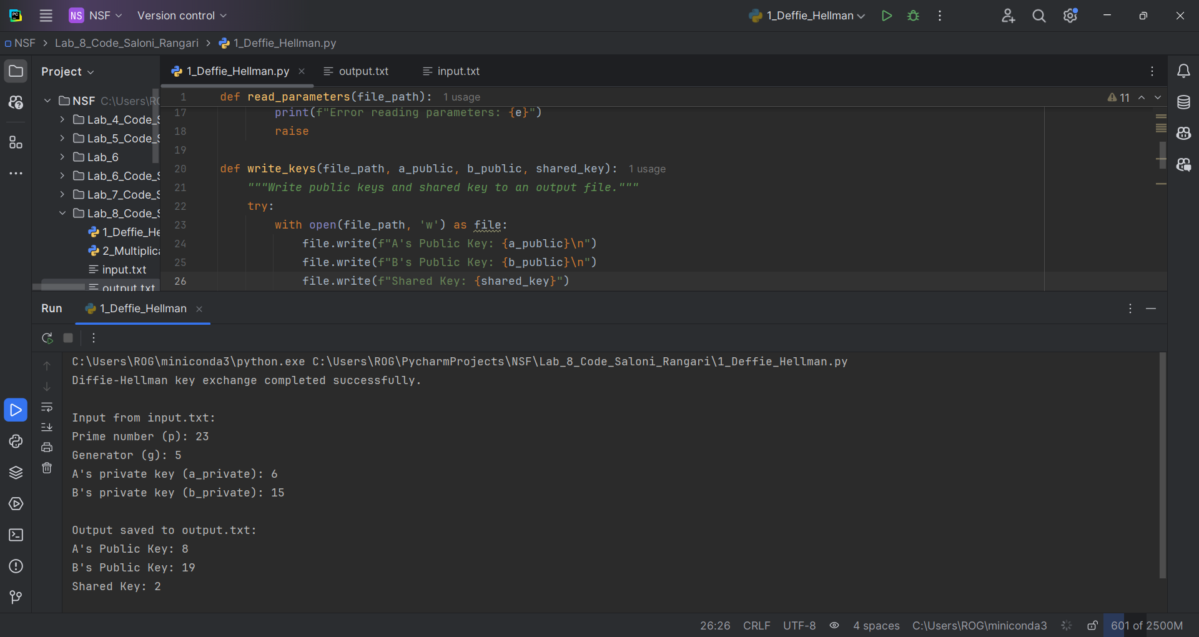

**Assignment 2: Write a program to calculate the multiplicative inverse of any number under mod operation.**

def extended_gcd(a,b):  
 if a == 0:  
 return b,0,1  
 gcd,x1,y1 = extended_gcd(b % a,a)  
 return gcd,y1 - (b // a) * x1,x1  
  
  
def multiplicative_inverse(a,m):  
 gcd,x,_ = extended_gcd(a % m,m)  
 if gcd != 1:  
 raise ValueError("Inverse doesn't exist")  
 return x % m  
  
  
if __name__ == "__main__":  
 print("Format: {number} * {multiplicative_inverse} mod {modulus} = 1\n")  
 number = int(input("Enter the number: "))  
 mod = int(input("Enter the modulus: "))  
  
 try:  
 inv = multiplicative_inverse(number,mod)  
 print(f"The multiplicative inverse of {number} modulo {mod} is {inv}.")  
 print(f"{number} * {inv} mod {mod} = 1")  
 except ValueError as e:  
 print(e)

**Output:**

